**JOB PORTAL SYSTEM**

* **Project Holders : Md Azhar and Pachipala Rambabu**

**Project Overview:**

* “The Job Portal System serves as a platform for job seekers and employers to connect and manage job applications. Job seekers can search and apply for jobs, while employers can post job openings, track applications, and manage the hiring process.”

### **Entities and Their Attributes**

#### **1. JobSeeker**

* **Attributes:**
  + **jobSeekerId (varchar, PK): Unique identifier for each job seeker.**
  + **name (varchar, NN): Full name of the job seeker.**
  + **email (varchar, NN, Unique): Email address of the job seeker.**
  + **password (varchar, NN): Password for the job seeker’s account.**
  + **phone (int, NN, Unique): Phone number of the job seeker.**
  + **createdAt (date, NN): Date when the record was created.**
  + **updatedAt (date): Date when the record was last updated.**
  + **skillId (varchar, FK): Links to a Skills table for associated skills.**

#### **2. Employer**

* **Attributes:**
  + **employerId (varchar, PK): Unique identifier for each employer.**
  + **companyName (varchar, NN): Name of the employer's company.**
  + **email (varchar, NN, Unique): Email address of the employer.**
  + **password (varchar, NN): Password for login.**
  + **phone (int, NN, Unique): Unique phone number of the employer.**
  + **address (varchar): Address of the employer's company.**
  + **createdAt (date, NN): Date when the employer registered.**
  + **updatedAt (date): Date when the record was last updated.**

#### **3. JobPost**

* **Attributes:**
  + **jobPostId (varchar, PK): Unique identifier for each job post.**
  + **employerId (varchar, FK): Links to the Employer table.**
  + **skillId (varchar, FK): Links to the Skills table for required skills.**
  + **categoryId (varchar, FK): Links to a Categories table for job categories.**
  + **title (char, NN): Title of the job post.**
  + **description (char): Detailed description of the job post.**
  + **jobTypeId (varchar, FK): Links to a JobType table.**
  + **location (varchar): Location of the job.**
  + **salary (int, NN): Salary offered for the job.**
  + **datePosted (date): Date when the job was posted.**
  + **status (varchar): Current status of the job post (e.g., open, closed).**
  + **createdAt (date): Date when the record was created.**
  + **updatedAt (date): Date when the record was last updated.**

#### **4. Application**

* **Attributes:**
  + **applicationId (varchar, PK): Unique identifier for each application.**
  + **jobPostId (varchar, FK): Reference to the JobPost entity.**
  + **jobSeekerId (varchar, FK): Reference to the JobSeeker entity.**
  + **status (varchar, NN): Status of the application (e.g., new, under review, interviewed, hired, rejected).**
  + **dateApplied (date, NN): Date when the job was applied for.**
  + **createdAt (date, NN): Date when the record was created.**
  + **updatedAt (date): Date when the record was updated.**

#### **5. Interview**

* **Attributes:**
  + **interviewId (varchar, PK): Unique identifier for each interview.**
  + **applicationId (varchar, FK): Reference to the Application entity.**
  + **date (date): Date of the interview.**
  + **time (timestamp): Timestamp for the interview time.**
  + **location (varchar): Location of the interview.**
  + **status (varchar, NN): Status of the interview (e.g., scheduled, completed, canceled).**
  + **createdAt (date, NN): Date when the record was created.**
  + **updatedAt (date): Date when the record was updated.**

#### **6. Category**

* **Attributes:**
  + **categoryId (varchar, PK): Unique identifier for each category.**
  + **name (varchar, NN): Name of the category (e.g., IT, Healthcare).**
  + **createdAt (date, NN): Date when the category was created.**
  + **updatedAt (date): Date when the record was updated.**
  + **jobPostId (varchar, FK): Links to the JobPost table.**

#### **7. Skill**

* **Attributes:**
  + **skillId (varchar, PK): Unique identifier for each skill.**
  + **name (varchar): Name of the skill (e.g., Python, Project Management).**
  + **createdAt (date, NN): Date when the skill record was created.**
  + **updatedAt (date): Date when the record was updated.**
  + **jobPostId (varchar, FK): Links to the JobPost table.**

#### **8. Feedback**

* **Attributes:**
  + **feedbackId (varchar, PK): Unique identifier for each feedback entry.**
  + **employerId (varchar, FK): Links to the Employer table.**
  + **jobSeekerId (varchar, FK): Links to the JobSeeker table.**
  + **message (varchar, NN): Feedback message.**
  + **createdAt (date, NN): Date when the feedback was created.**

#### **9. JobType**

* **Attributes:**
  + **jobTypeId (varchar, PK): Unique identifier for each job type.**
  + **name (varchar, NN): Name of the job type (e.g., full-time, part-time).**
  + **createdAt (date, NN): Date when the job type was created.**
  + **updatedAt (date): Date when the record was updated.**
  + **jobPostId (varchar, FK): Links to the JobPost table.**

#### **10. Role**

* **Attributes:**
  + **roleId (varchar, PK): Unique identifier for each role.**
  + **name (varchar, NN): Name of the role (e.g., Admin, User, Employer).**
  + **createdAt (date, NN): Date when the role record was created.**
  + **updatedAt (date): Date when the record was updated.**
  + **jobSeekerId (varchar, FK): Reference to the JobSeeker entity.**
  + **employerId (varchar, FK): Reference to the Employer entity.**

#### **11. Resume**

* **Attributes:**
  + **resumeId (varchar, PK): Unique identifier for each resume.**
  + **jobSeekerId (varchar, FK): Reference to the JobSeeker entity.**
  + **filePath (varchar, NN): File path of the resume.**
  + **createdAt (date, NN): Date when the record was created.**
  + **updatedAt (date, NN): Date when the record was updated.**

**Tables :**

**1. JobSeeker** :

| **Field Name** | **Field Type** | **Constraint** | **Description** |
| --- | --- | --- | --- |
| jobSeekerId | varchar | PK | Unique identifier for each job seeker. |
| name | varchar | NN | Full name of the job seeker. |
| email | varchar | NN , Unique | Email address of the job seeker. |
| Password | varchar | NN | Password for the job seeker’s account. |
| Ph.no | int | NN, Unique | Phone number of the job seeker. |
| createdAt | date | NN | Date when the record was created. |
| updatedAt | date |  | Date when the record was last updated |
| skillId | varchar | FK | Links to a skills table for associated skills. |

**2. Employer :**

|  |  |  |  |
| --- | --- | --- | --- |
| **Field Name** | **Field Type** | **Constraint** | **Description** |
| Employer_id | varchar | PK | Unique employer id to identify employee |
| companyName | varchar | NN | Name of the company of employer |
| Email | varchar | Nn, Unique | Email id of employer |
| Password | varchar | NN | Password for login |
| phone | int | Nn,unique | Unique Phone number of employer |
| address | Varchar |  | Address of company |
| createdAt | date | NN | Date when employer registerd |
| updatedAt | date |  | Date when record updated |

**3. JobPost :**

|  |  |  |  |
| --- | --- | --- | --- |
| **Field Name** | **Field Type** | **Constraint** | **Description** |
| jobPostId | varchar | PK | Unique identifier for each job post. |
| employerId | varchar | FK | Links to the Employer table (e.g., employer creating the post). |
| //skillId | varchar | FK | Links to the Skills table for required skills. |
| categoryId | varchar | FK | Links to a Categories table (e.g., job categories). |
| Title | char | NN | Title of the job post. |
| description | char |  | Detailed description of the job post. |
| jobTypeId | varchar | FK | Links to a JobType table (e.g., full-time, part-time). |
| location | varchar |  | Location of the job. |
| salary | int | NN | Salary offered for the job. |
| datePosted | date |  | Date when the job was posted. |
| status | varchar |  | Current status of the job post (e.g., open, closed). |
| createdAt | date |  | Date when the record was created. |
| updatedAt | date |  | Date when the record was last updated. |

**4. Application:**

|  |  |  |  |
| --- | --- | --- | --- |
| **Field Name** | **Field Type** | **Constraint** | **Description** |
| ApplicationId | varchar | PK | Unique identifier for each application |
| jobPostId | varchar | FK | This is the reference to jobpost entity |
| jobSeekerId | varchar | FK | This is the reference to *jobseeker* entity |
| status | varchar | NN | Shows the current status of the application on status (new, under review, interviewed, hired, rejected). |
| dateApplied | date | NN | Date when applied to job |
| createdAt | date | NN | Date when record is created |
| updatedAt | date |  | Date when record is updated |

**5. Interview:**

|  |  |  |  |
| --- | --- | --- | --- |
| **Field Name** | **Field Type** | **Constraint** | **Description** |
| interviewId | varchar | PK | Unique identifier for each interview. |
| applicationId | varchar | FK | Links to the Application table (e.g., the job application associated with the interview). |
| date | date |  | Date of the interview. |
| time | timestamp |  | Timestamp for the interview time. |
| location | varchar |  | Location of the interview. |
| status | varchar | NN | Current status of the interview (e.g., scheduled, completed, canceled). |
| createdAt | date | NN | Date when the interview record was created. |
| updatedAt | date |  | Date when the interview record was last updated. |

**6. Category:**

|  |  |  |  |
| --- | --- | --- | --- |
| **Field Name** | **Field Type** | **Constraint** | **Description** |
| categoryId | varchar | PK | Unique identifier for each category. |
| name | varchar | NN | Name of the category (e.g., IT, Healthcare). |
| createdAt | date | NN | Date when the category was created. |
| updatedAt | date |  | Date when the category was last updated. |
| jobPostId | varchar | FK | Links to the JobPost table. |

**7. Skill:**

|  |  |  |  |
| --- | --- | --- | --- |
| **Field Name** | **Field Type** | **Constraint** | **Description** |
| skillid | varchar | PK | Unique identifier for each skill. |
| name | varchar |  | Name of the skill (e.g., Python, Project Management). |
| createdAt | date | NN | Date when the skill record was created. |
| updatedAt | date |  | Date when the skill record was last updated. |
| jobPostId | varchar | FK | Links to the JobPost table for associated job posts. |

**8. Feedback:**

|  |  |  |  |
| --- | --- | --- | --- |
| **Field Name** | **Field Type** | **Constraint** | **Description** |
| feedbackId | varchar | PK | Unique identifier for each feedback entry. |
| employerId | varchar | FK | Links to the employer table (e.g., the user giving the feedback). |
| jobSeekerId | varchar | FK | Links to the jobseeker table (e.g., the user giving the feedback). |
| message | varchar | NN | Feedback message from the employer/jobseeker. |
| createdAt | date | NN | Date when the feedback was created |

**9. JobType :**

|  |  |  |  |
| --- | --- | --- | --- |
| **Field Name** | **Field Type** | **Constraint** | **Description** |
| jobtypeId | varchar | PK | Unique identifier for each job type. |
| name | varchar | NN | Name of the job type (e.g., full-time, part-time). |
| createdAt | date | NN | Date when the job type was created. |
| updatedAt | date |  | Date when the job was last updated, |
| jobPostId | varchar | FK | Links to the JobPost table for associated job posts. |

**10. Role :**

|  |  |  |  |
| --- | --- | --- | --- |
| **Field Name** | **Field Type** | **Constraint** | **Description** |
| roleId | varchar | PK | Unique identifier for each role. |
| name | varchar | NN | Name of the role(e.g., Admin, User, Employer) |
| createdAt | date | NN | Date when the role record was created. |
| updatedAt | date |  | Date when the role record was last updated. |
| jobSeekerId | varchar | FK | Foreign key referencing the Job Seeker entity. |
| employerId | varchar | FK | Foreign key referencing the Employer entity. |

**11. Resume :**

|  |  |  |  |
| --- | --- | --- | --- |
| **Field Name** | **Field Type** | **Constraint** | **Description** |
| resumeId | varchar | PK | Unique identifier for each job offer. |
| jobseekerId | varchar | FK | Links to the jobseeker .table |
| filepath | varchar | NN | Resume file path |
| createdAt | date | NN | Date when the offer record was created. |
| updatedAt | date | NN | Date when the offer record was updated. |

**Relationships :**

1. **JobSeeker → Resume**

* One-to-One: A single job seeker can upload single resume.

2. **JobSeeker → Application**

* One-to-Many: A job seeker can apply for multiple job posts.

3. **Employer → JobPost**

* One-to-Many: An employer can post multiple job listings.

4. **JobPost → Category**

* Many-to-One: A job post belongs to a specific category (e.g., IT, Finance).

5. **JobPost → Application**

* One-to-Many: A job post can have multiple applications submitted.

6. **Application → Interview**

* One-to-One: Each application can have a scheduled interview.

7. **Application → Resume**

* One-to-One: Each application can result in one Resume.

8. **JobPost → JobType**

* Many-to-Many: A job post is associated with a job type (e.g., Full-time, Part-time, Work from Home etc). One JobType can be associated with multiple JobPost and a JobPost can be associated with multiple JobType.

9. **JobSeeker → Skill**

* Many-to-Many: A job seeker can have multiple skills, and a skill can belong to multiple job seekers.

10. **JobPost → Skill**

* Many-to-Many: A job post can require multiple skills, and a skill can belong to multiple job posts.

11. **Employer → Feedback**

* One-to-One: An Employer can send feedback.

12. **Jobseeker → Feedback**

* One-to-One: A Jobseeker can send feedback.

13. **Employer → Role**

* Many-to-Many: Each Employer can have multiple Roles.

14. **JobSeeker → Role**

* Many-to-Many: Each JobSeeker can have multiple Roles.

**Summary :**

### **1. JobSeeker**

* 1:1: Resume, Feedback.
* 1:Many: Application.
* Many:Many: Skill, Role

### **2. Employer**

* 1:1: Feedback.
* 1:Many: JobPost
* Many:Many: Role

### **3. JobPost**

* 1:Many: Application
* Many:1: Category.
* Many:Many: JobType, Skill

### **4. Application**

* 1:1: Resume, Interview.

### **5. Skill**

* Many:Many: JobSeeker, JobPost.

### **6. JobType**

* Many:Many: JobPost

### **7. Role**

* Many:Many: JobSeeker, Employer

**ER DIAGRAM**

**1. JobSeeker** → Resume, Feedback, Application, Skill, Role

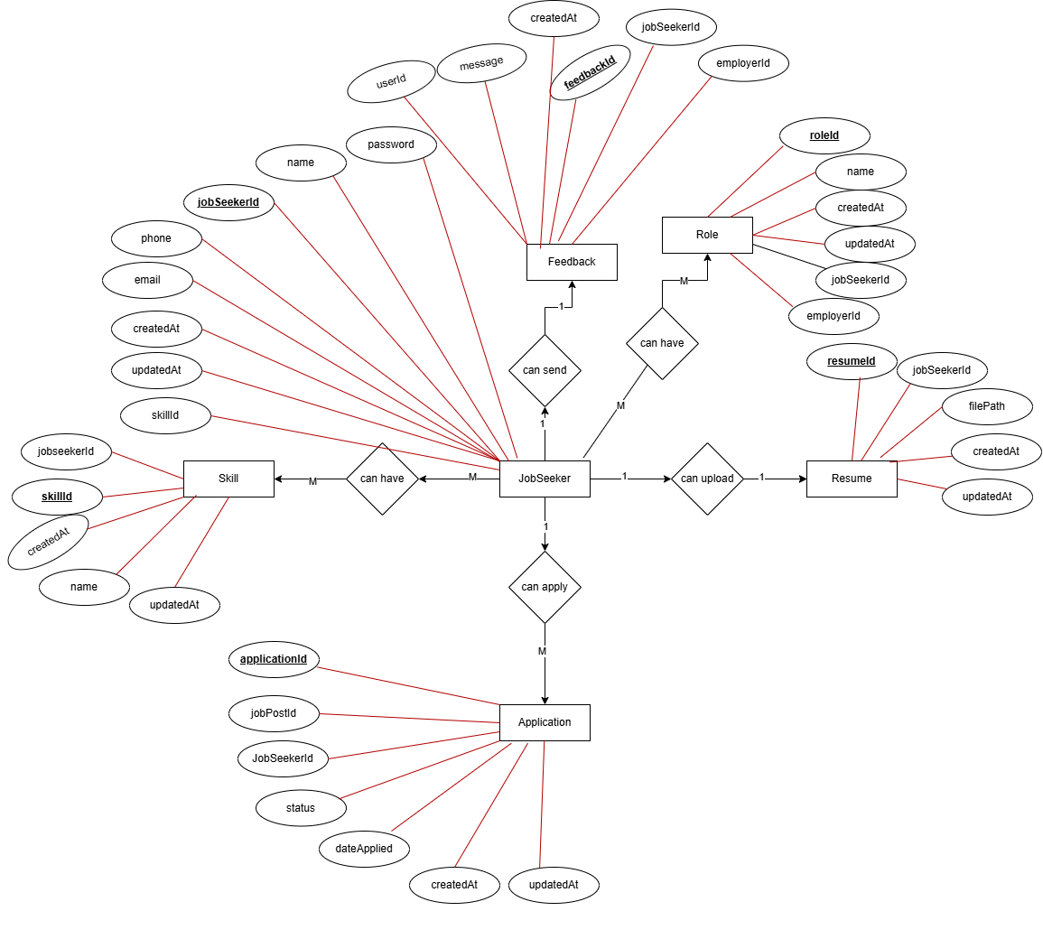

### **2. Employer** → Feedback, JobPost, Role

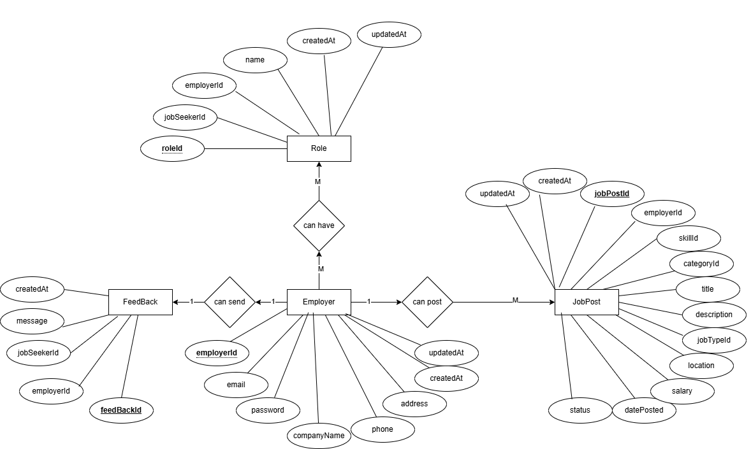

### **3. Job Post** → Employer, Skill, Category, JobType

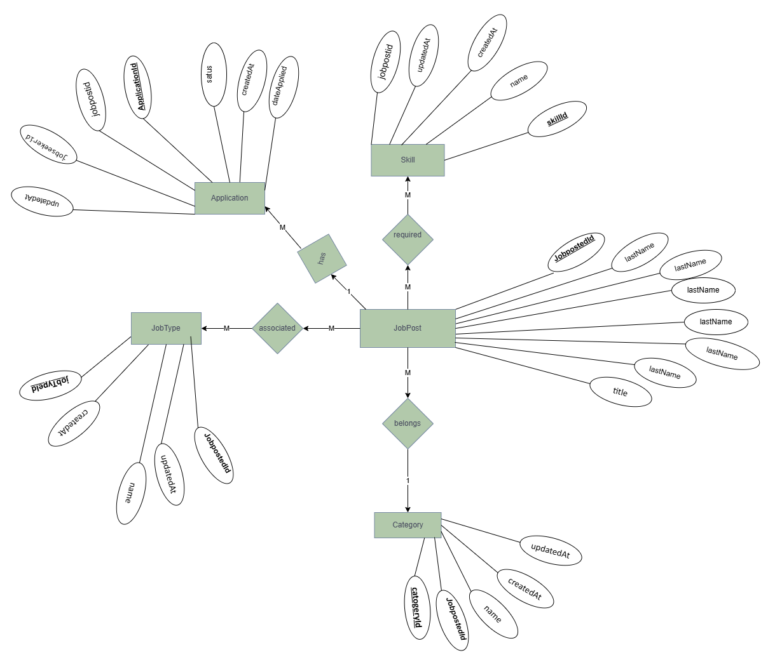

### **4. Application** → Resume, Interview

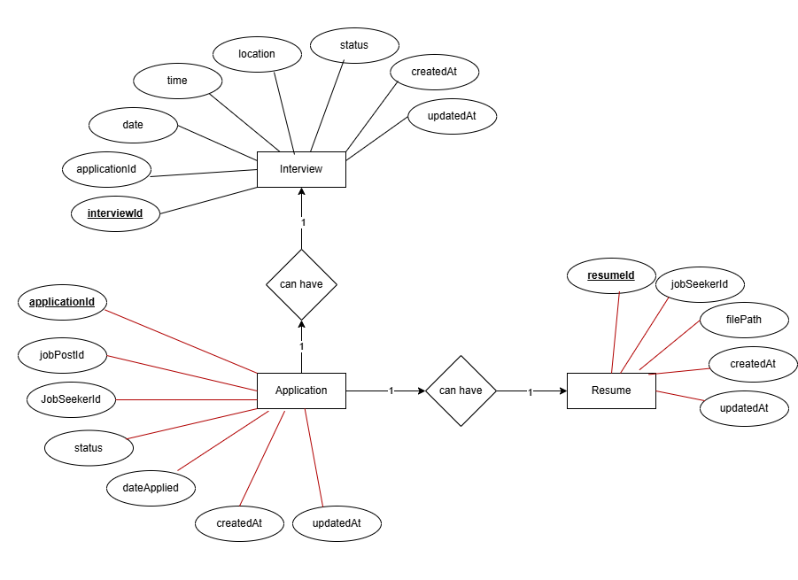

### **5. Skill** → JobSeeker, JobPost.

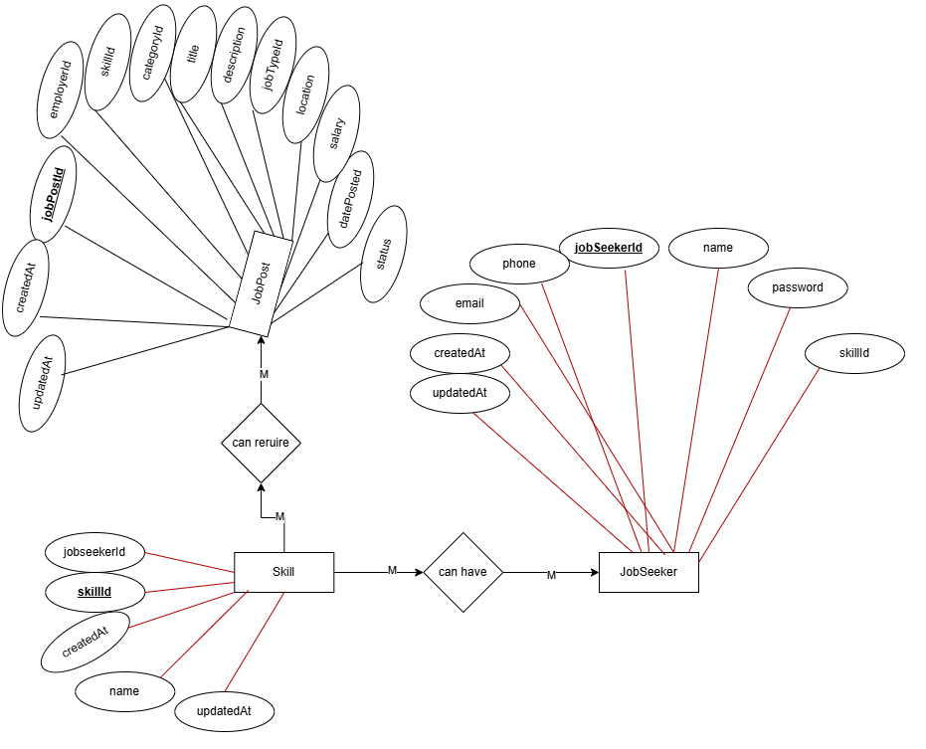

### **6. JobType** → JobPost

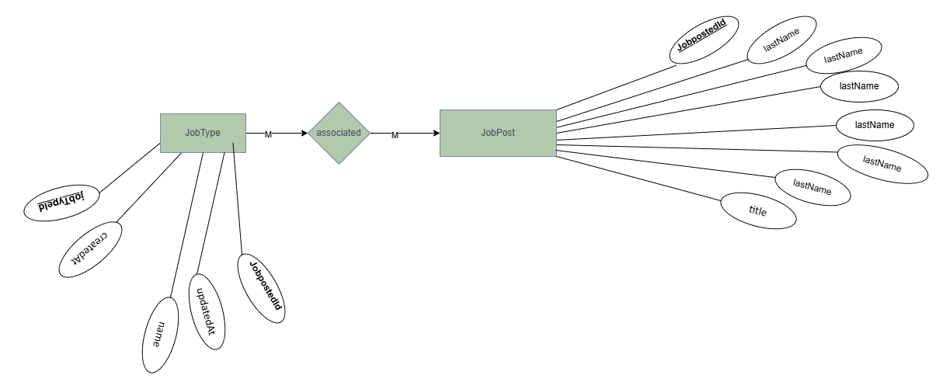

### **7. Role** → JobSeeker, Employer

